

Technical Specification Document – Master Data Synchronization

FULLERTON HEALTHCARE PTE LTD

Author: [Srinivasan .M]
Date: [2015,September,16th]
Version: [1.0]

Document Control
Document location
Location
Abeo Electra , Chennai, Tamilnadu, India
Author
Position | Name | Contact no
Technical Consultant | Srinivasan .M | +91 9865316889
Revision history
Version | Issue date | Author/editor | Description/Summary of changes
Reviewed by
Version | Issue date | Name | Position | Reviewdate
Approvals
Approval refers to the approver’s acceptance of the content and overall intention of this document, including acceptance of any commitments described in order to successfully deliver the initiative. The approver, where relevant, also confirms that this document complies with relevant strategies, policies and regulatory requirements.
Version | Issue date | Name | Position | Approval date
Related documents
Document | Location
Table of Contents
1 INTRODUCTION 4
1.1 Objectives 4
1.2 Scope 4
1.3 Development Environment 4
2 Functionality 5
2.1 Use Case Diagram 5
2.2 Site Map 5
2.3 Field Matrix 8
3 Achitecture 9
3.1 Architecture Overview 9
4 Design 10
4.1 Object Diagram 10
4.3 Data Dictionary 11
5 CODE 12
5.1 Coldfusion File Names and Structure 12

1. INTRODUCTION

1.1 Objectives
This document is a generic technical design document for the projects. It provides guidance which is intended to assist the relevant management, technical staff or client. It is also useful background reading for anyone involved in customization or monitoring the Master Data Synchronization Add-on.

1.2 Scope
This preface describes:
- Design UI for passing some valid inputs and select the Master Data Type and choose the Sync code range and display the company details in matrix.
- Create UDT for storing the company information like, DBCode, DBName, SAPUsername and SAPPassword.
- Master Data Type is having two values only. 1. User 2. Chart of Account.
- Based on Master Data Type selection, choose the range of codes in sync code.
- Choose the Databases in the matrix to create/update master data
- After the button click in the UI, it will connect to the Target Company and Create/Update the Users’/COAs’ in the target company one by one, which is selected in the matrix.
- If any error occurs, display in status bar. If need more information, Need to refer the DebugLog.Log and ErrorLog.Log which is in add-on installed path.
- If it`s not fails, the system will post the master data in respective company in SAP B1 and update the status in matrix.

1.3 Development Environment
- This Solution is a True Add-on, Developed in VS2010 with using SAP B1 9 DLLs.

IDE: Visual Studio 2010
.Net Framework: 4.0
SAP Components: SAP B1 SDK, UIAPI, DIAPI

2. Functionality

2.1 Use Case Diagram

SAP B1

UI Input Screen
Parameters -> Master data type, Sync code range, CompanyDB

Validation
1) Should select the Master Data Type from the drop down list. If not select will prompt error message in status bar

2) Choose the Master Codes range. If it’s empty then prompt error message in status bar

3) Should select at least one company in the matrix. Otherwise will prompt error message in status bar

Master Data Create/Update
While Creating/Updating the master data in SAP B1, if any error occurs this function will prompt the error message and continue to the next record if no errors will update success message and continue.

2.2 Site Map
The applications site map showing the navigation streams.

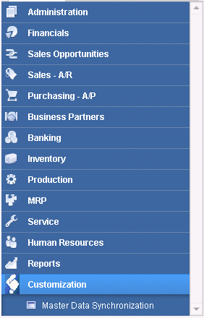

SAP B1 Menu -> Customization -> Master Data Synchronization

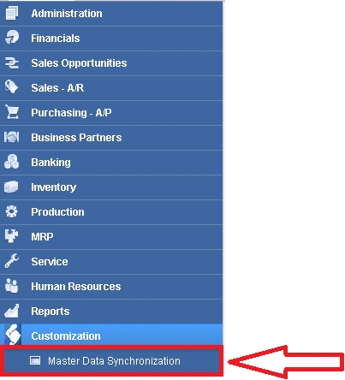

Upon clicking the menu “Master Data Synchronization” the below form will display

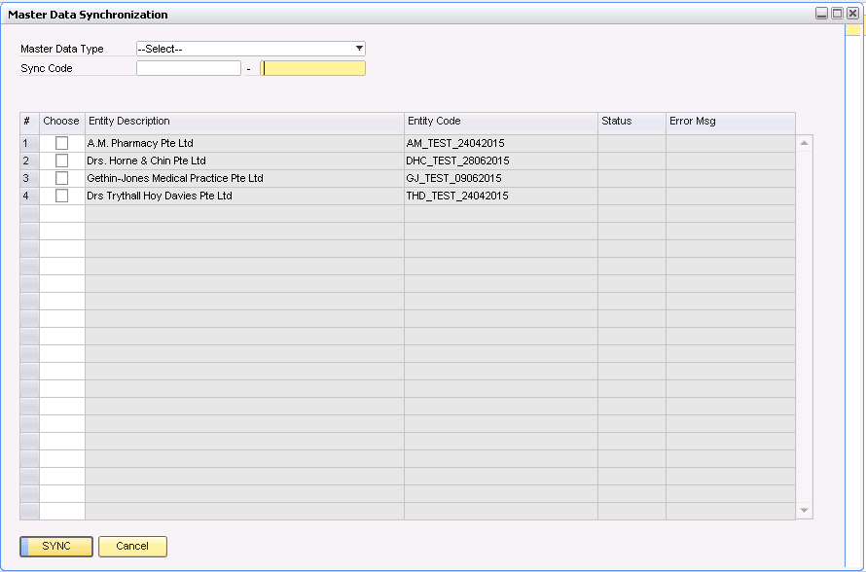

Key in the following inputs in the below screen
- Select the master data type, whether User/Chart of Accounts
- Choose the sync code range
- Choose the databases which want to do the synchronization.

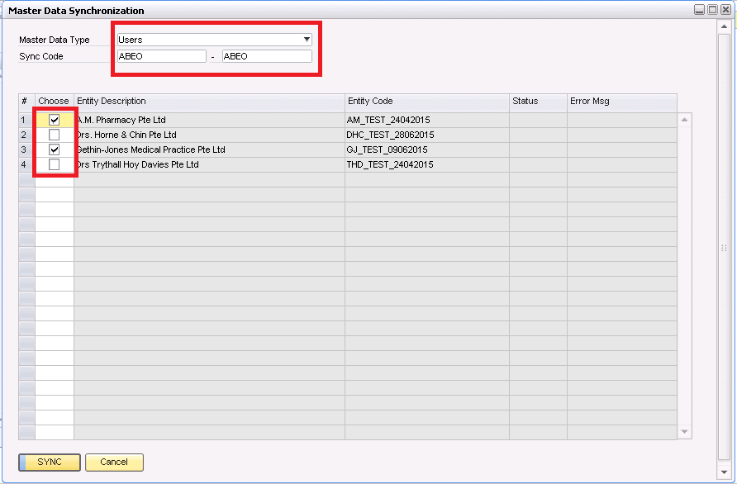

Validations:
Upon clicking the “SYNC” button, the following validation will be done.

#1 if Master Data Type dropdown haven’t select any value, show the error message in status bar. Please refer below screen shot.

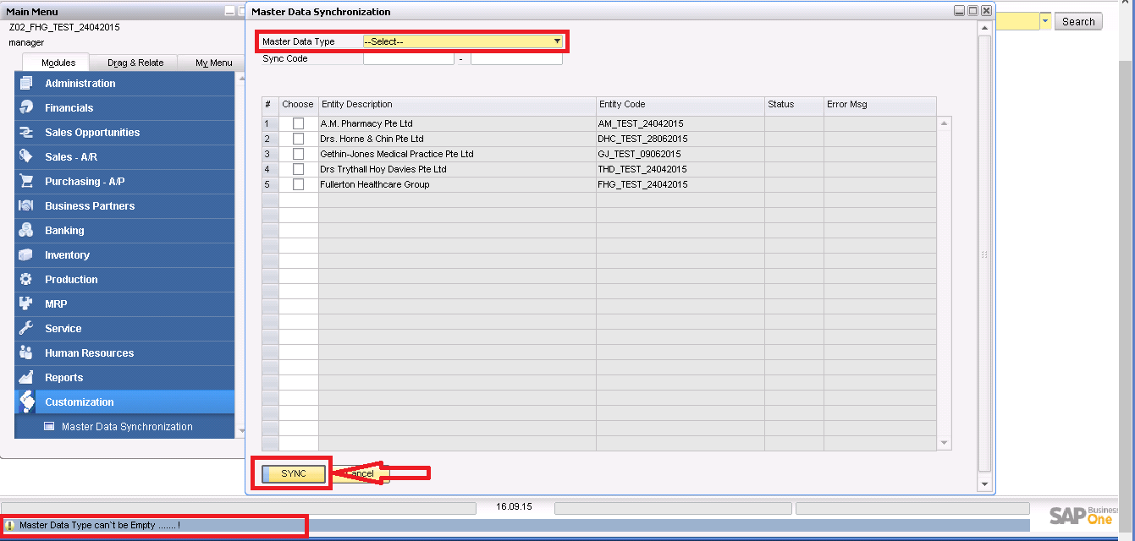

#2 If user haven’t choose the Sync Code range, show the error message in status bar. Please refer below screen shot.

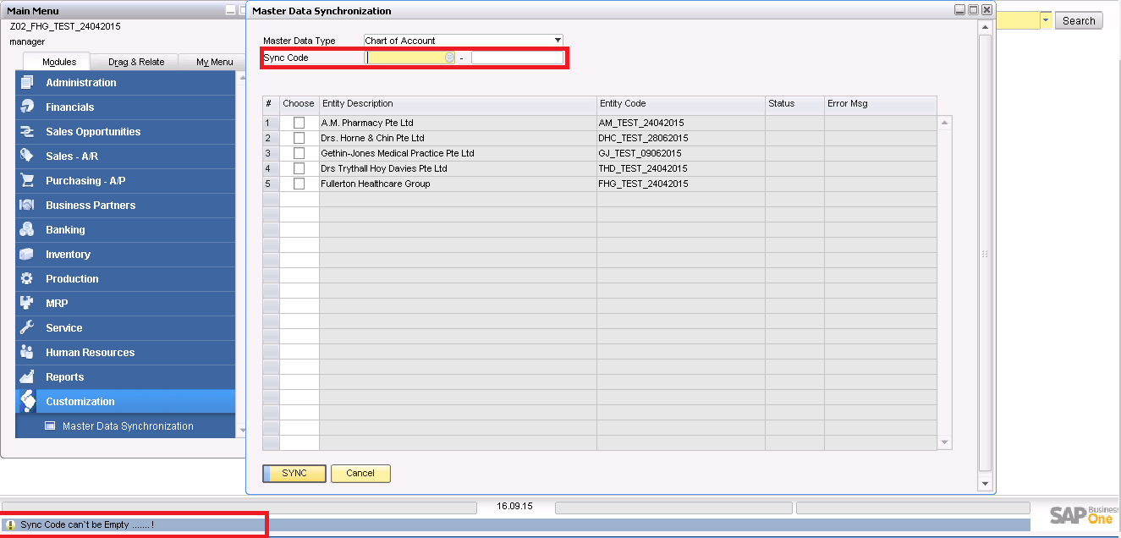

#3 2 If user haven’t choose the entity in the matrix, show the error message in status bar. Please refer below screen shot.

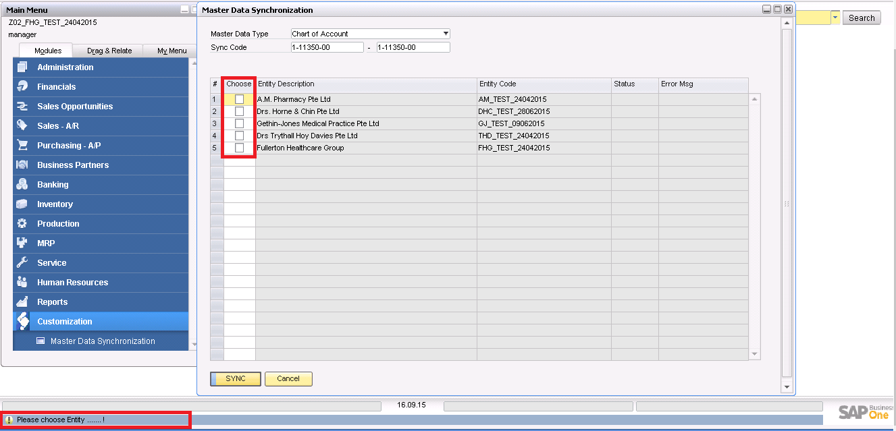

2.3 Field Matrix
Fullerton having multiple entities to sync the master data’s. A User Defined Table (UDT) has been created in SAP Business One under the company to serve this purpose.

This table contains the entity credentials to create/update the master data’s.

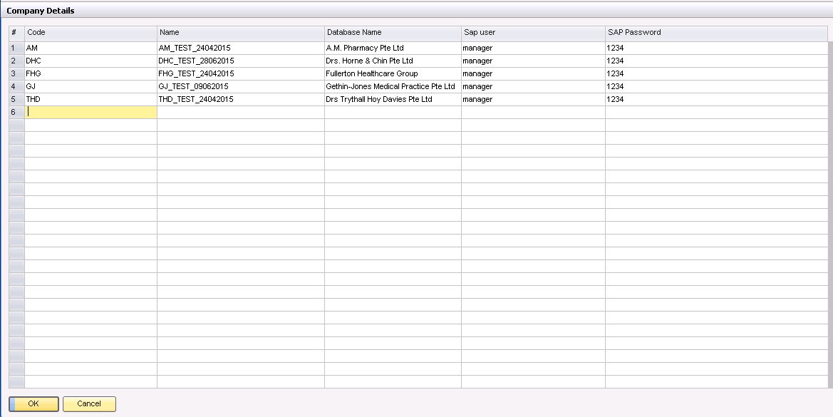

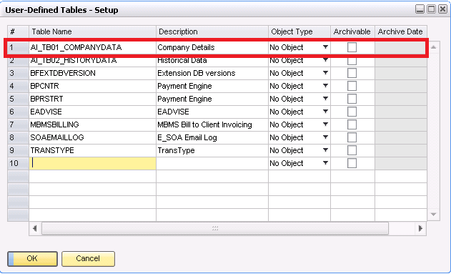

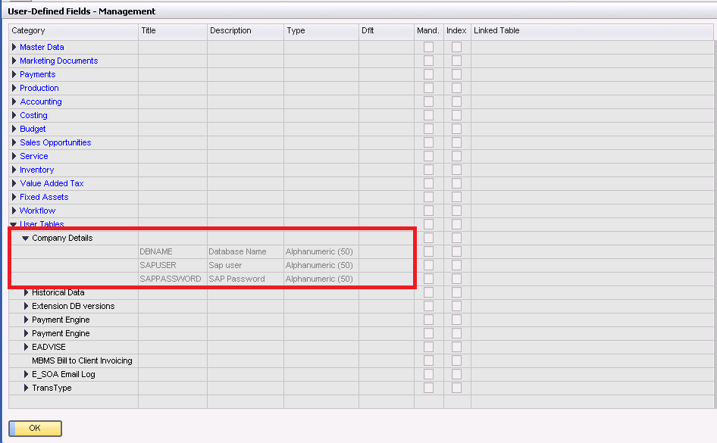

User needs to provide the Entity credential during design stage. After go-live, user will have to maintain this table.

Tools → User-Defined Windows → AI_TB01_COMPANYDATA – Company Details

3. Architecture

Architecture Overview

Master Data Synchronization
Finance Module

GUI
Chart of Account
It will start with validation process one by one, if it`s succeed it will step in next validation, once the validation are completed. It will Add/Update
COA/Users in SAP B1.

Business Logic
Administration

User

SQL Server (DB)

4. Design

Object Diagram
A diagram of all of the participating classes and all of the objects methods.

modMain.vb
ClsEventHandler.vb

Calling ConnectDICompSSO()
Calling AddMenuItems()
SBO_Application_AppEvent()
SBO_Application_MenuEvent()
Calling LoadFromXML()
Calling EntityLoad()
SBO_Application_ItemEvent()
BeforeAction = False
EventType = ComboSelect
ItemUID = "Item_0"
Calling ClearMatrix()
Calling AddChooseFromList_COA()
Calling CFL_DataBindingUser()
Calling AddChooseFromList_User()
BeforeAction = True
EventType = ItemPressed
ItemUID = "btnGntFile"
Calling Clear_Matrix()
Calling HeaderValidation()
Calling DisplayStatus()
Calling ConnectToTargetCompany()
Calling MasterDataSync()
Calling EndStatus()

modCommon.vb

Description ConnectDICompSSO()
Description AddMenuItem()
Description LoadFromXML()
Description HeaderValidation()
Description Clear_Matrix()
Description ConnectToTargetCompany()
Description MasterDataSync()
Description AddChooseFromList_COA()
Description AddChooseFromList_User()
Description CFL_DataBindingUser()
Description WriteTextFile_SyncLog()
Description Create DataTable()
Description AddDataToTable()
Description WriteLogFiles()

modChartofAccounts.vb
modLogging.vb
Description ChartofAccounts()

Description WriteToLogFile()
Description WriteToLogFile_Debug()

user.vb

Description UsersSync()

Data Dictionary
Descriptions of all the fields and Tables in the system.
Fullerton having multiple entities to sync the master data’s. A User Defined Table (UDT) has been created in SAP Business One under the company to serve this purpose.

This table contains the entity credentials to create/update the master data’s.

UDF Details

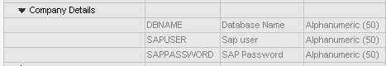

Sample Data

5. Code

Coldfusion File Names and Structure
The purpose for the methods/ function in this solutions.

Module and Class Name:

- modMain.vb
Initializing some public variables and calling the SAP Company connection method.
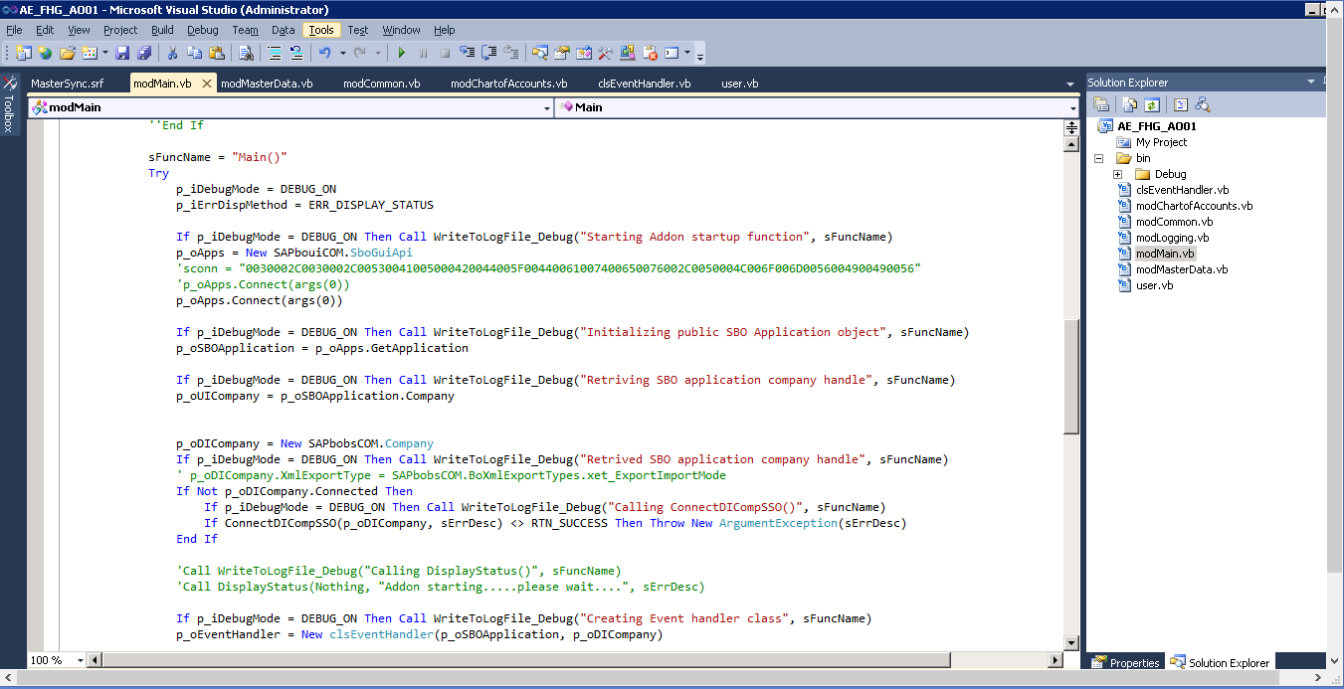

- clsEventHandler.vb

Event handler class having the main three events
- AppEvent
It will triggers when the connections / disconnection happen with the company database.

- MenuEvent
It will triggers any menu is clicked / pressed.
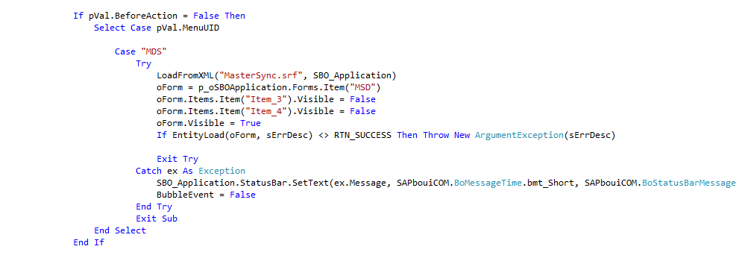

- ItemEvent
For Master Data Sync - Double Click
DisplayStatus() – This function will handles the display the status message in separate form
EndStatus() – This function will handles the close the status message form

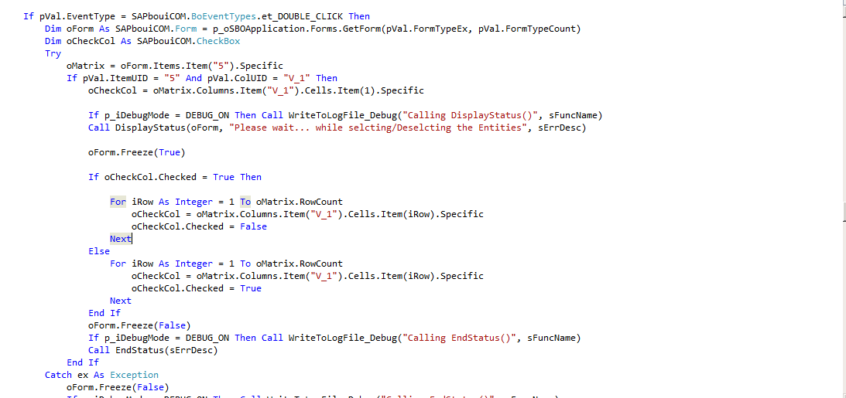

For Master Data Sync - Button Click

Clear_Matrix() – This function will handles clear the status column and error message column in matrix
Validation() - This function will handles the validation part and if any validation fails, it will prompt the msg.
DisplayStatus() – This function will handles the display the status message in separate form
ConnectToTargetCompany() – This function will handles to connect the target company
MasterDataSync() - This function will handles to Add/Update Master data in SAP.

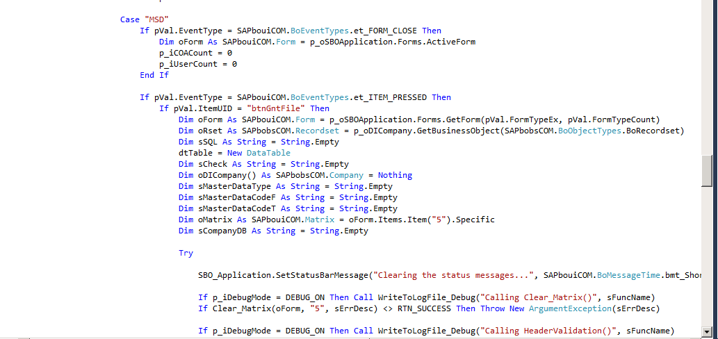
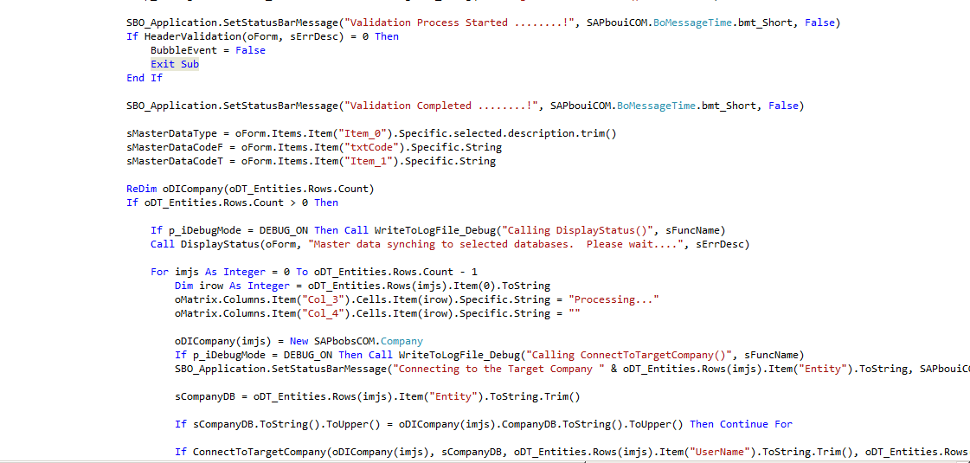

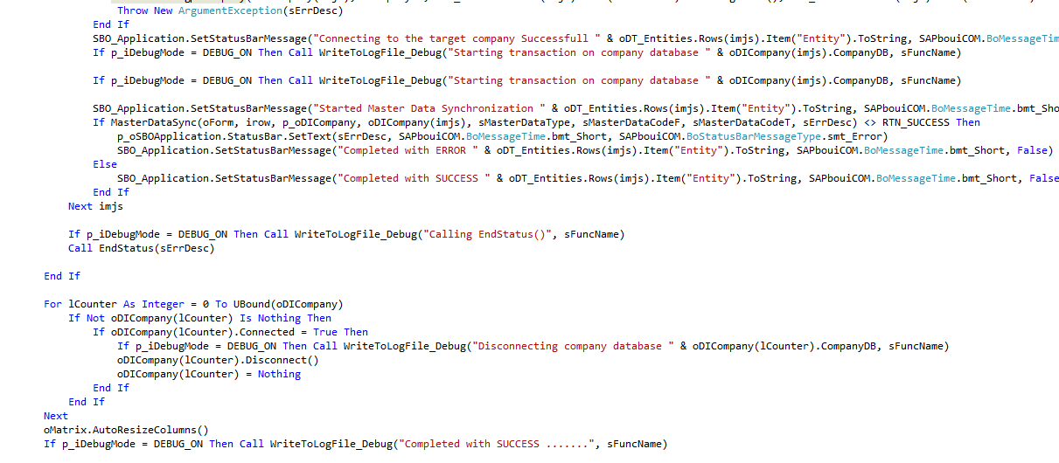

- modCommon.vb

AddMenuItems() - Creating the Menus in the SAP B1 GUI.
LoadFromXML() - Used to open the .srf file.
HeaderValidation() - Validates the GUI .
Clear_Matrix() – Clear the status messages in Matrix
ConnectToTargetCompany() –Connect to the target company
MasterDataSync() – Create/Update the master data in target company
AddChooseFromList_COA() – Create CFL for COA object
AddChooseFromList_User() – Create CFL for User object
CFL_DataBindingUser() – Bind the CFL ID and field in the UI text boxes
WriteTextFile_SyncLog() – Create the sync logfiles
CreateDataTable() – Create new datatable
AddDataToTable() – Add the data into an existing datatable
WriteLogFiles() – Write the log files for sync status

